# Installation process

I installed Ansible on CentOS7.

1. Install the EPEL repository

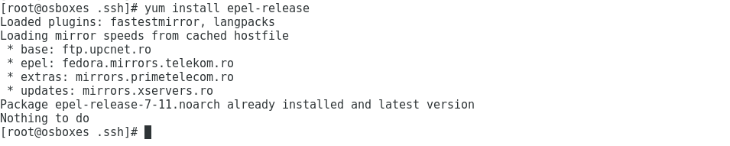

1. 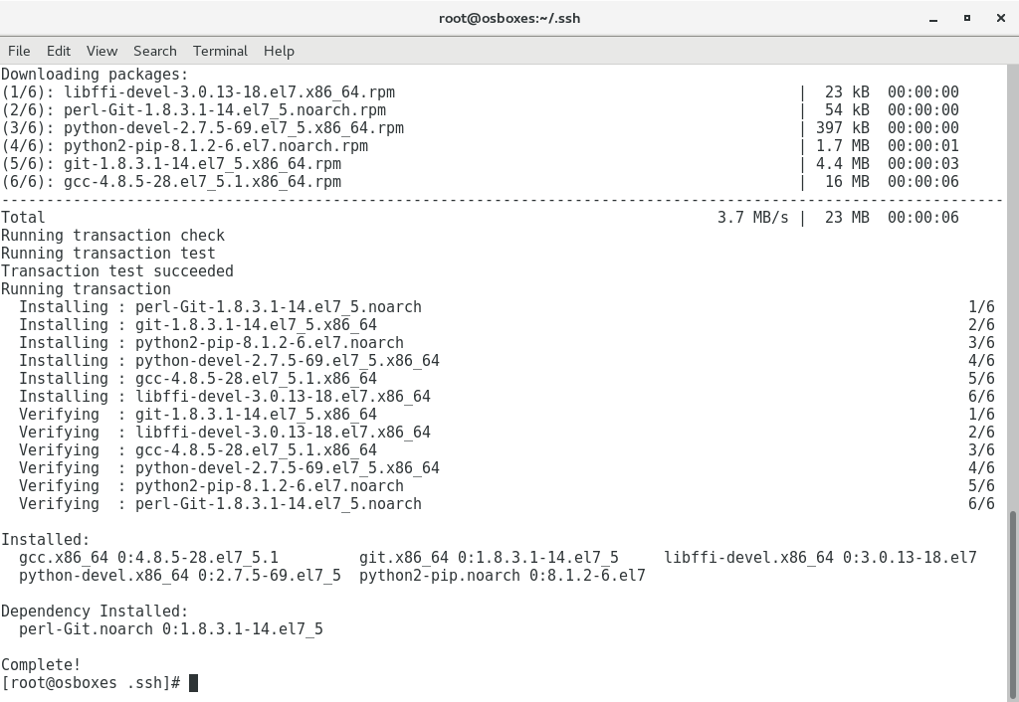Installing some Python tools and libraries
2. Installing the set-up tools

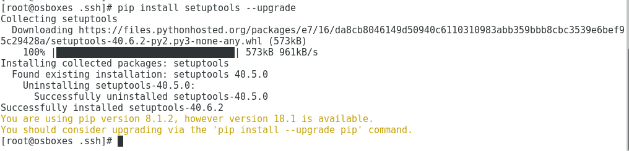

1. Installing Ansible

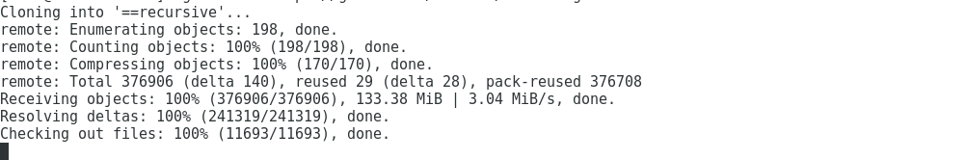

Checking the installation of Ansible with “ansible” command:

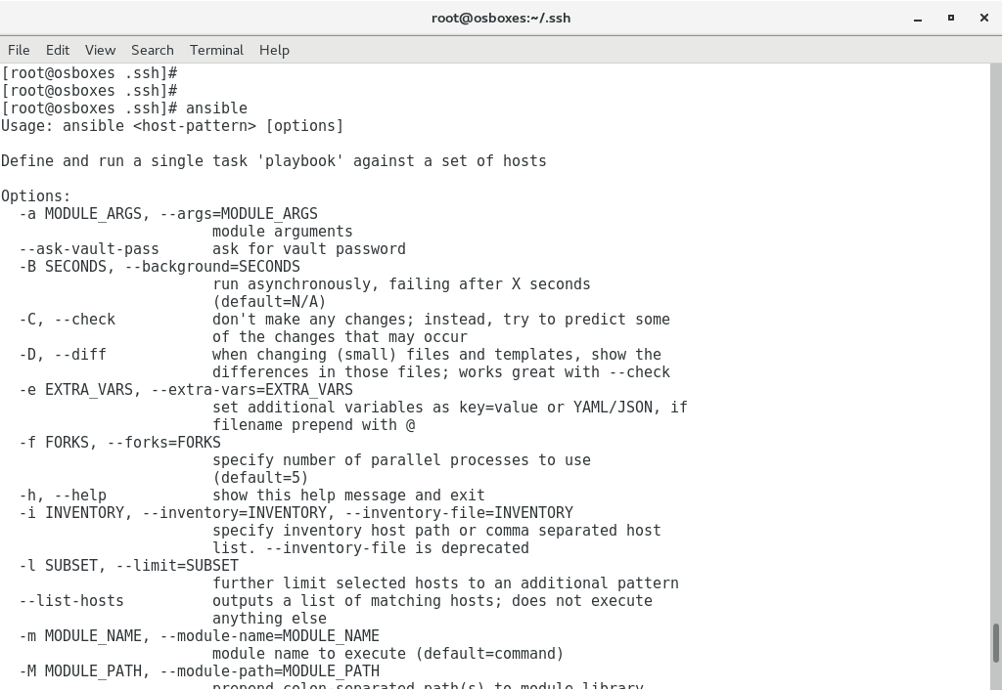

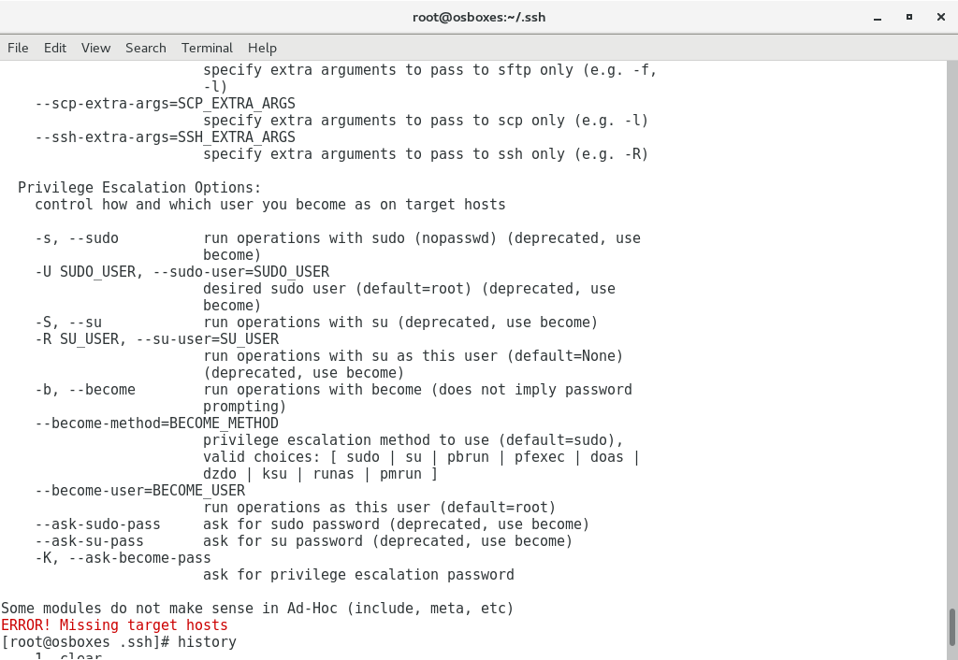

1. Generating the SSH key authentication:

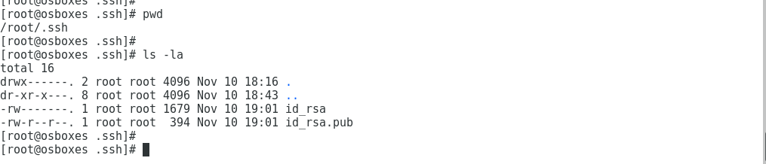

1. Public key

